myDamco Administrator Guide

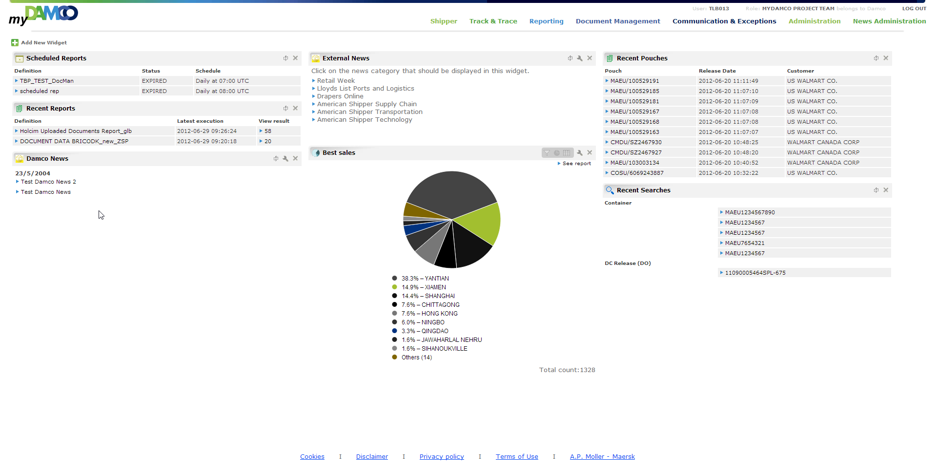

# Introduction

This document describes how to use the administration tool for myDamco version 4.6.0. The guide is not intended for myDamco Supporters, Developers or End Users, but Administrators of the myDamco Portal.

MyDamco is a web-based gateway into the Damco application landscape, for both customers and employees.

Contents

Introduction 3

1: UAM authorization and access rights 5

2: News 6

2.1 Creating and editing Damco News Items 6

2.2 Announcements 8

2.2.1 Creating and editing announcements 8

2.2.2 Creating downtime as part of announcements 9

2.2.2.1 What happens during down time 11

2.3 Creating and editing News categories 12

2.3.1 Mixing news from one or more RSS feeds with the Damco News 13

3: Navigation 15

3.1 Managing the applications in the navigation menu 15

3.2 Portal or External applications 16

3.2.1 Portal applications 16

3.2.2 External applications 17

4: Widgets 19

4.1 Widget creation tutorial 19

5: Pages 26

5.1 Creating a new page 26

6: Statistics 28

7: Settings 29

8: Dashboard Templates 31

8.1 How to create a dashboard template 31

8.2 How to update a dashboard template 33

8.3 Refreshing organizations and roles from UAM 33

9: Server management 34

# UAM authorization and access rights

Explaining the difference between UAMOperation, UAMFunction and UAMApplication, is best done with an example.

The Damco Application Track & Trace is in UAM defined as a UAMApplication, with the name - REPORTING_TRACKTRACE. In order to be able to access Track & Trace a user must be a member of a UAM-role, which includes the UAMApplication REPORTING_TRACKTRACE.

UAMOperation is used to differentiate between the user’s rights and roles in Track & Trace. For instance, some users should “operate as” administrators, others as editors or ordinary reporting users etc. This is accomplished with UAMOperation.

A UAMFunction is a UAMApplication plus a UAMOperation.

Users are given rights in UAM, by being added to a UAM-role which contains a range of UAMFunctions.

For myDamco users to be able to enter the administration tool, the user needs to have Administration or Editor rights for the myDamco application - that is, having the UAMFunction UAM:MYDAMCO:ADMINISTRATION or UAM:MYDAMCO:EDITOR.

Administrators have full access to the administration tool, when seeing “Administration” in the Navigation Menu. Editors only have partial access to the news section of the administration tool, which is shown as “News Administration” in the Navigation Menu. This is to allow editors to create news for the “Damco News” widget, but disallow them from accessing the rest of the administration tool.

Administrators can create news as well as announcements, setup the links displayed in the navigation menu, edit widgets, see statistics on the usage of widgets, perform Server Management and create simple web pages hosted directly in the myDamco application.

Due to historical events, the usage of the terms UAMOperation and UAMFunction is sometimes switched around in myDamco. When creating e.g. an navigation menu link the admin has to specify a UAMApplication and a UAMFunction, instead of a UAMApplication and a UAMOperation. Please be aware of that when reading this guide.

# News

In the news section of the administration tool, you can create news items for the Damco News widget, create announcements to be shown to all users and create downtime to inform users when an application at Damco is scheduled to be taken down for maintenance. This part of the administration tool is available to Editors as well as Administrators of myDamco. Editors will however only be able to create news items, not create announcements.

## Creating and editing Damco News Items

Creating, editing and deleting news items for the Damco News widget happens from the "Damco General News" tab of the News section.

To create a news item, go to the "Damco General News" tab and click the "Create New" button (seeFigure 1). This will cause the dialog shown on Figure 2 to appear. When editing a news item, the exact same dialog is shown, so only the process of creating news items will be described here.

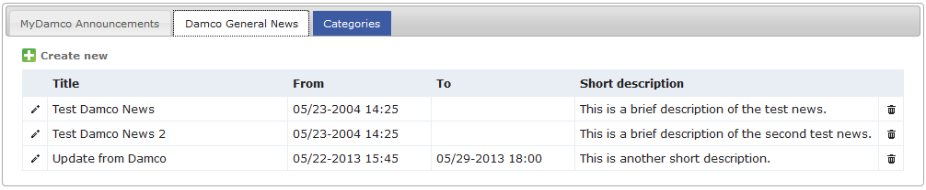

Figure 1: The Damco General News tab shows all news items for the Damco News widget.

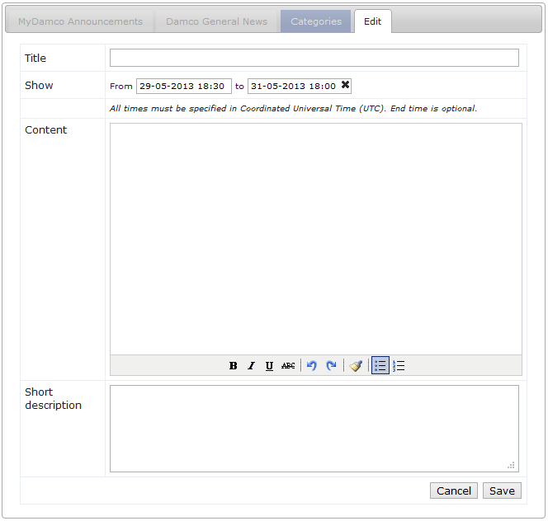

Figure 2: The create/edit news item dialog.

The dialog contains fields that must be filled out in order to create the news item. These fields will be briefly described here.

First, you have to enter a title for the news item. The title is shown in the Damco news widget.

A news item has a start time and optionally an end time. The item will not appear in the Damco News widget, until it reaches the start time. If you specify and end time, the news will automatically disappear from the widget again, at that point in time. If no end time is specified, it will stay in the widget indefinitely (or until it is manually removed).

When clicking the start time or end time field, a date and time selector will appear which lets you select the date and time. Note that these times must be specified in Universal Coordinated Time (UTC)[1]. As mentioned, if you want the news item to automatically be removed at some specific point in time, you should specify an end time, otherwise you leave it blank (click the "X" icon).

Write the actual content of the news article in the content section. The buttons at the bottom of this input area, can be used for formatting the text. This content is shown to the users when they click the title of the news item in the widget. This takes them to a page where they can read your article in its entirety.

A short summary of the news item can also be specified in the "Short Description" text field.

Finally, after having clicked the save button, your news item has been created and will be displayed to the users when its start time is reached.

A news item may later be edited using the pencil button to the left in the news list. The creation and last update (when and by who) is shown in the news list for administrators.

## Announcements

An announcement is a message displayed on the dashboard of all users (Figure 3), regardless of the chosen widgets on the dashboard. They are intended to be used for conveying important messages to all users.

Announcements should only to be shown during a limited period of time, rather than being a permanent message. Since announcements are shown directly on the dashboards of the users and make quite an impact of the look & feel of the site, they should be kept to a minimum. They are designed to visually stand out from the rest of the page and are hard for the users not to notice.

One example of using announcements, is for informing users that a Damco application is scheduled to be taken down for maintenance. This particular use case has special support by the system: Links and widgets relying on that application are deactivated during its downtime. See the downtime section below for more information on this subject (section 2.2.2).

Note that only a single announcement can be shown at any given time.

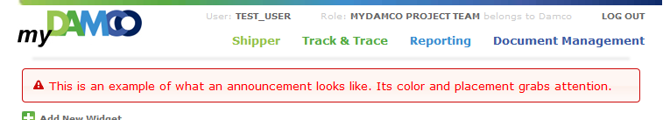

Figure 3: This is how an announcement looks like to the users.

### Creating and editing announcements

Creating, editing and deleting announcements is done from the "myDamco announcements" tab of the News section.

The process of creating an announcement is almost identical to the process of creating a news item described above. Internally in the system, an announcement is actually a special kind of news item, so it is no coincidence that this process is similar.

As when creating news items, to create an announcement, you must click the "Create New" button. This causes a dialog to appear that looks nearly the same as the dialog for creating news items.

Again, you start by entering a title for the announcement. This title is not currently displayed to the users in the widget. It will however be shown in the administration page, so this field is mostly for internal organization among the administrators.

Like before, you need to specify the time for when the announcement is shown and optionally when it is to be removed again. You should usually specify an end time, otherwise the announcement will be active until removed manually.

The Content section of an announcement is unused. The message which is to be shown to the users, must be written in the "Short Description" text field.

Finally, clicking the save button creates the announcement.

Please note, that the user has to refresh the page (press F5, click the myDamco logo or the refresh button in the browser), in order to see the result of the announcement just saved.

### Creating downtime as part of announcements

One of the main use cases for announcements is to inform the users that a certain Damco application will be down for scheduled maintenance during a specific period of time. You can specify this by adding filling out from- and to-time in the announcement.

While the application is down, the links to the particular application in the navigation menu (if any) will be deactivated and any widgets depending on that application will be deactivated as well. During this downtime period, information boxes will appear when users hover their mouse pointer over the deactivated links in the navigation menu or over the deactivated widgets in the “add widget” dialog. The information will also be displayed on any affected widgets the users have already placed on their dashboards instead of their usual content. This will be described in more detail in section 2.2.2.1.

If you want use an announcement to specify that a certain system will be down for a certain period of time, you specify this by clicking "Add Downtime" button in the create/edit dialog of the announcement. When you do this, the following dialog will appear:

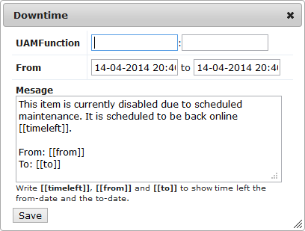

Figure 4: The downtime dialog.

In this dialog, in the left input box you can specify the UAM Application, which will be down and when it will be down. You can also edit the message which will be shown to the users, or just use the standard message.

The time format used in myDamco to specify downtime is UTC[2].

You may also optionally specify a UAMOpertation. This field should normally be left blank. You should only enter a value here, if you do not want to deactivate all links and widgets related the given application. This is elaborated below.

When you are typing in these fields, what you write will automatically be autocompleted, to known names of UAMApplications and UAMOperations. Clicking the save button, adds this downtime to your announcement. (See Figure 5)

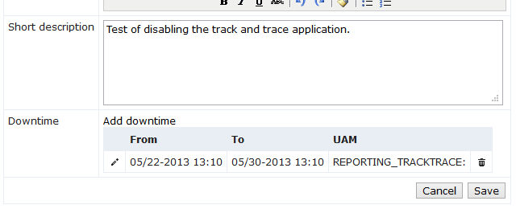

Figure 5: When a downtime entry has been created it appears in the create announcement dialog.

It is possible to add multiple down time entries to the same announcement.

This can be useful, for example, in case a system is scheduled to go down for maintenance multiple times during a short period of time, or in case multiple different systems are scheduled to be taken down.

It is recommended to set the start time of the announcement prior to when the down time begins, to give the users a warning that the system(s) will be taken down before it actually happens.

You can also edit or delete downtime items, by clicking the corresponding icons.

#### What happens during down time

When an application is down, according to the downtime entries you entered in the announcement, a few things will happen in the User Interface of myDamco.

First of all, the link (if any) to the application in the navigation menu will be greyed out (see Figure 6).

When a user hovers the mouse pointer over the deactivated link, a box will appear explaining that the system is down for scheduled maintenance and when it is expected to come back up.

Secondly, if there are widgets relying on the application, they will be deactivated.

If a user already has such widget on his dashboard, it will, just like the mouse over, contain an explanation informing the user that the system currently is down (see Figure 6).

Furthermore, these widgets will also be greyed out in the "add widget" dialog, so that the user cannot drag these widgets onto their dashboards during the downtime. Again, an explanation message is shown on mouse over (see Figure 7).

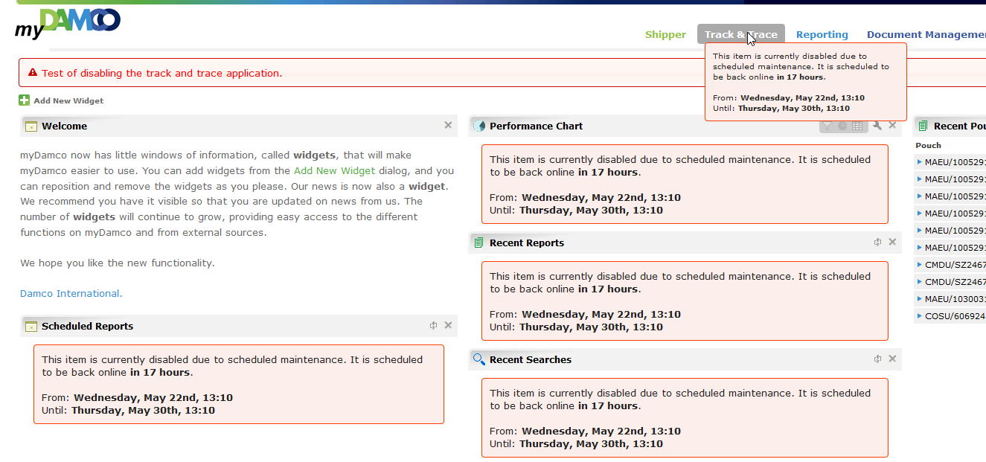

Figure 6: This is an example of the Track & Trace application being deactivated. The navigation link has been greyed out and has a mouse over explaining why it has been deactivated. This warning is displayed in the widgets on the dashboard as well.

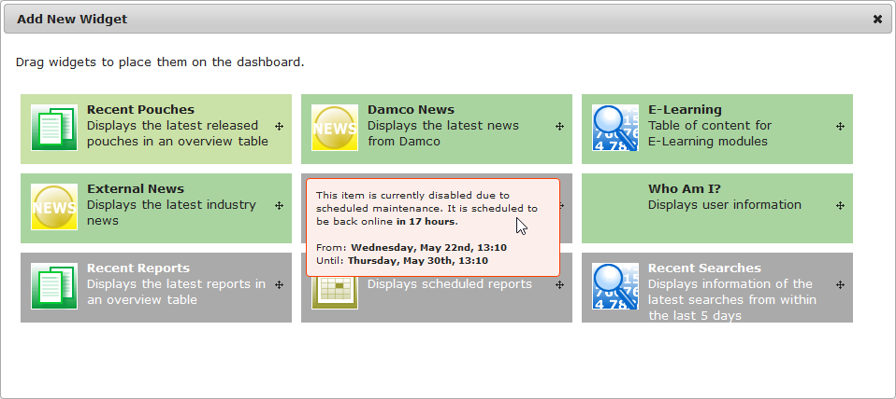

Figure 7: This shows how the Add New Widget dialog looks with widgets deactivated. The deactivated widgets are greyed out and shows an explanation of why they are deactivated when hovering the mouse over them.

When creating a downtime announcement, it is recommended to keep UAMOperation field blank and only enter a value in the UAMApplication field. Most often when an application is down, it is the entire application and not just a specific part, only relevant for a specific UAMOperation, which is down.

The widgets getting deactivated by this, are exactly those having this UAMApplication associated with them in the Widget section of the administration tool.

To view the UAMApplication associated with a widget, click the “Edit” button for that widget. When the UAMOperation field is left blank in the dialog, all UAMOperations are included in the downtime.

If you enter both a UAMApplication and a UAMOperation, only the navigation links and widgets which are *both* associated with the application *and* the function will be deactivated. Again, you can see this in the Navigation and Widget sections of the administration tool.

## Creating and editing News categories

All news items belongs to a category. For example, all announcements belongs to the “Announcements” category and all news items in the Damco News widget belongs to the “Damco General News” category (at the time of writing).

In the categories tab of the news section, you can see the current news categories. By default, there are only two: “Announcements” and “Damco General News”. Announcements are special, as we have seen above, but more categories like the Damco General News category can be created. New categories can for example be used to allow the user to select between multiple news category in the Damco News widget, or a new widget can be made which shows the news items from the new category.

Creating a new category in itself is easy, but to make the news from the new category appear in a widget, also requires editing the configuration of the widget to make it show that category – for now it is probably best if a developer does this.

### Mixing news from one or more RSS feeds with the Damco News

For the Damco News widget (and the news archive pages), it is possible to mix one or more external feeds with the internal news items from the “Damco General News” category.

This is done by editing the “Damco General News” category, and clicking “Edit” in the Configuration column. In the popup which opens, you enter information about the external RSS feed which you would like to mix with the internal news. (This is written in a format called JSON, and it is important that it is valid JSON for it to work)

**Examples:**

To not include any external feeds, simply write “{}”:

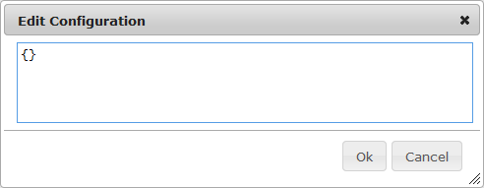

Figure 8: No external feeds associated with the news category

To include the news from the damco.com RSS feed (as it currently done):

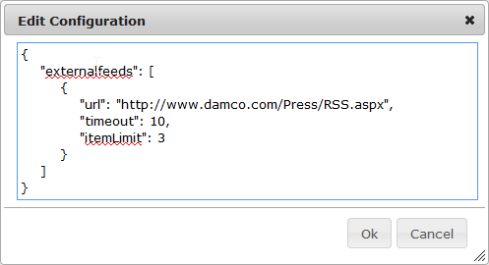

Figure 9: Example of one external feed associated with the news category

Explanation of the values:

* **url:**The URL of the RSS feed to mix with the internal news.
* **itemLimit:**The maximum number of items from the external feed to show in the Damco News widget (and on the news page, unless it is showing the archive).
* **timeout: (optional)**The maximum number of seconds to wait for getting response from the external site before giving up. This should not be sat too high – if the setting is too high, it will also slow down myDamco, in case the other server responds slowly. It shouldn’t be sat too low either. The default is 10 seconds.

To include the news from two external RSS feeds:

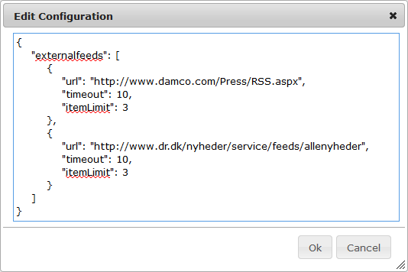

Figure 10: Example of two external feeds associated with the news category

The above example will mix the news from both RSS-feeds with the internal news. Including the news from 3 or more external RSS feeds is done in a similar manner.

# Navigation

In the navigation section of the administration tool, it is possible to setup which links are to be shown to the users in the navigation menu. This section will explain how this is done.

New links to new Damco applications can be added to the navigation menu. To ensure a consistent user experience across the various applications at Damco, the navigation menu of myDamco should be displayed in these applications as well. Note that the developers of the target application may or may not have to make changes to their application for the navigation menu to appear in their application. This is also discussed in this section.



Figure 11: The navigation menu

## Managing the applications in the navigation menu

When entering the navigation section of the administration tool, a table of the current navigation items is shown. These are the links currently displayed in the navigation menu. Note, that most of these require certain rights in order to be displayed, so not all users will see all of these.

In this section of the administration tool, you can create new navigation items, as well as edit and delete existing items. You can also change the order in which the links are shown to the users, by dragging and dropping the items in the table. They are shown is the same order to the users as they are shown in the table.

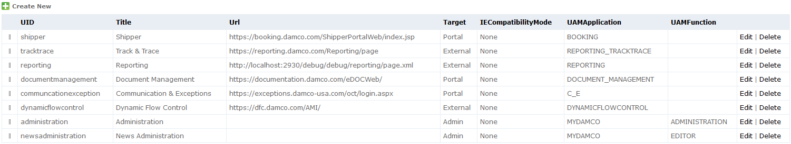

Figure 12: The table in the navigation section of the administration tool, showing each link of the navigation menu.

The columns of the table will be described here:

* **UID:**  
  This is a name which must be unique among all the UIDs of the other navigation items.
* **Title:**   
  The name of the application shown in the navigation menu.
* **Url:**   
  The URL to the application.
* **Target:**   
  This can be “Portal”, “External” or “Admin”. Admin is reserved for internal use only. The difference between Portal and External applications is described below.
* **IECompatibilityMode:**  
  This should usually be set to “None”.  
  Possible values are: “None”, “EmulateIE7”, “EmulateIE8”, “EmulateIE9”, “IE5”, “IE7”, “IEEdge”. This setting only affects Portal applications; it is ignored for External applications. Technically, it sets the “x-ua-compatible” header, in case the target application requires a legacy document mode to function properly.
* **UAMApplication/UAMFunction:**  
  The rights a user is required to have for the link to the application to be shown in the navigation menu. This should correspond to the rights required for entering the application.   
    
  Note that the UAMFunction can be empty, meaning that the navigation item will be visible to users as long as they have any rights in the application (doesn't matter which). For this reason, it is usually desirable to leave it empty.

## Portal or External applications

In the previous section each column of the navigation table was described, except for the meaning of “Portal” and “External” of the Target column. This section will describe the difference between portal and external applications. The difference lies in how the navigation menu is embedded into the target application.

When adding a new application to the navigation menu, it is important to analyze which of the two approaches is most suitable for the application in question and to discuss it in close collaboration with the developers of that application. One approach might be better suited for some applications, while the other is more suited for others. None of the solutions are perfect and each has its advantages/drawbacks which are elaborated below.

### Portal applications

If an application is defined as a portal application, in the Target row of the navigation table, the application will be embedded in an iframe by the myDamco application, which will ensure that the navigation menu is shown at the top of every page of the application. The advantage of this approach, is the application itself in general does *not* have to do anything for this to work - apart from not disallowing being embedded in an iframe by myDamco.

It works as follows: When navigating to a portal application, the browser is not directed directly to the real URL of the web application. Instead, the browser is directed to our page at:

<https://portal.damco.com/Applications/><uid>/

where <uid> is the UID chosen in the administration tool (described above). This page takes care of showing the navigation menu and embedding the portal application in an iframe.

The main disadvantage of the portal approach, is that it might not work well with all types of applications. Since the application is actually displayed as part of a page on myDamco, it does not have full control of what is sent to the browser (HTTP headers, for example).

Another possible disadvantage is that when users are using the application, their browsers will always show the myDamco URL in their address line, no matter what subpage of the portal application they are visiting. This means that they cannot bookmark individual pages of the application, share links with each other, copy/paste the link, etc. It might also be a disadvantage for some applications, that a portal application does not have control of the entire browser window.

A refresh (hitting F5, the browser refresh button or clicking the myDamco logo) will alwas bring the user back to the frontpage of the portal application. This might not be what the user intends, when working in e.g. Document Management and doing a refresh and landing back at the frontpage of Document Management.

To make “deep links” from myDamco into a portal application is cumbersome. An example could be linking from the chart widget into a specific report in the Reporting Portal application. To perform this, you need to link to both the widget and the specific report in the same URL, e.g. ([https://portal.damco.com/Applications/<uid>/Link/<someparams>/?<otherparams](https://portal.damco.com/Applications/%3cuid%3e/Link/%3csomeparams%3e/?%3cotherparams)>). When the user clicks refresh here, he is redirected back to the specific page and does not stay on the deep linked page the user has clicked into.

Another thing to be aware of with portal applications, is that they must never go to a HTTP page or redirect to a HTTP url (except if they open the HTTP page in a new window). Due to a new security feature in Chrome, newer versions of the Chrome browser will block the portal application if it does that, which means that the iframe will show nothing. This is because myDamco runs on secure HTTPS, and Chrome disallows iframes on HTTPS to contain insecure HTTP content, since that would make users believe the content is secure, while it in reality is not. It is however still possible to see the portal application, by clicking the “shield icon” in the right-hand side of the address bar in Chrome and then clicking “load insecure script”, but this icon is well hidden and easy not to notice[3]. Other browsers will probably follow Chromes example in the future. Damcos portal applications should however always stay on HTTPS and never go to HTTP or jump between HTTP and HTTPS, for security reasons, but it is a restriction to be aware of nevertheless.

### External applications

If an application is defined as an external application, in the table, it is the application’s own responsibility to show the navigation menu. The disadvantage of this is naturally that the developers of the application needs to be more involved.

To include the navigation menu, the developers of the application must include our JavaScript on every page at which the navigation menu must be shown, using a <script> tag:

<script src="<https://portal.damco.com/Globalmenu/menuV2.js>"></script>

There could be conflicts between the JavaScript and CSS of the navigation menu and that of the application, so it might require coordination between the application developers and the myDamco development team.

The advantage of this approach is that it doesn't have the drawbacks of the portal approach. The external application is in full control of the browser and subpages can now be bookmarked, refreshed etc.

However, the embedding of the menu in the application does happen after the external application is loaded. This “redrawing” of the page is not always pretty. In rare cases, the menu does not appear until after approximately 5 seconds, where the page is pushed down. Another scenario where the menu takes approximately 5 seconds to load is if a user clicks a bookmark, e.g. a link to a Report, which does not require ADFS-login to myDamco.

# Widgets

In the widget section of the admin pages, you can see the list of all widgets currently available on myDamco.

From here it is also possible to edit and delete existing widgets as well as to create new widgets based on existing widget templates – i.e. to create new widgets which are variations of the existing widgets (such as a new Damco News widget, showing different news than the original does). However, since this is highly technical and requires a rather in-depth knowledge about myDamco, it should involve a developer.

It is also possible to export and import a widget to or from a file. Prior to making any changes to a widget, it is strongly recommended to export the widget first, so that the change can be undone, in case of unexpected results. Again, it is strongly advised to either do this in corporation with a developer.

While editing a widget is mostly for advanced users, there are some fields which can be edited without having to understand the underlying code base of myDamco. If you click the "Edit" link of a widget, you're taken to the edit page of that widget. Among the fields that could be changed without a deeper understanding of the system, would be the Title of the widget and the deactivated check box, which will completely deactivate a widget, until it is unchecked again.

The edit page also allows you to see the rights required for a user to have access to the given widget.

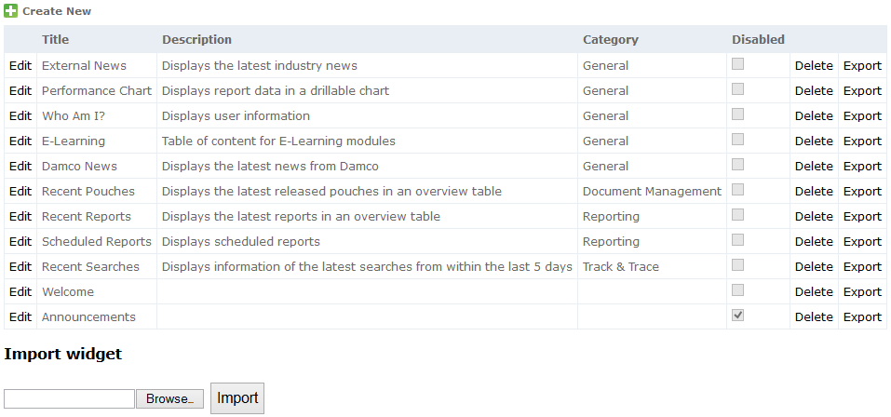

Figure 13: The widget page of the administration tool.

## Widget creation tutorial

This section is a tutorial in how to create a widget, using the e-learning widget as example.

First, navigate to the Widget part of the administration panel. If you don’t see the Administration panel, your UAM privileges are insufficient.

Then, click “Create New”, like shown below:

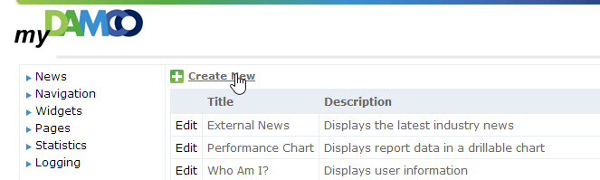

Figure 14: Create Widget.

The input fields in the form are explained below.

**UID** need to be a unique ID that has not been used for widgets before.

**Title** is displayed at the top of the widget, when added by the user.

**Description** is displayed at the Widget menu under the Administration menu.

**Category**. Pick the appropriate category between the ones below, or create a new. Categories are used to order widgets, in the view “Add New Widget”. If left blank the widget is not shown:

* General
* Document Management
* Reporting
* Track & Trace

**Template**. Use an existing template, for the widget layout, business logic and for using the input in the fields ServiceConfiguration and Configuration. There are the following templates available:

* RSSNews
* PerformanceChart
* WhoAmI
* ELearning
* RecentPouches
* RecentReports
* ScheduledReports
* RecentSearches
* StaticContent

**Configuration**. In the E-learning widget example the following input was used. This is the URL called by the widget:

{

"targeturl": "Services/ELearningShow"

}

**Configuration Schema.** Insert curly brackets:

{}

**Service Configuration**. System setup input for the widget. In the E-Learning example, the information below was used. The button “view source” lists the input texts in an unformatted style:

{

"folders": [

{

"application": "Reporting",

"folder": "C:\\newlearning\\SystemA",

"UAMApplication": "REPORTING",

"width": 1031,

"height": 804

},

{

"application": "Booking",

"folder": "C:\\newlearning\\SystemB",

"UAMApplication": "BOOKING",

"width": 1031,

"height": 804

}

]

}

A folder at the locations listed in Service Configuration must exist on the server.

**Service Configuration Schema**. Leave it empty.

**UAMApplication.** Fill out with:

MYDAMCO.

**UAMFunction:**

USE

Now save the widget.

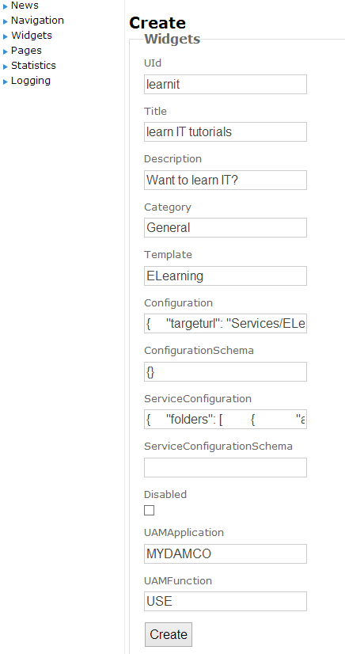

Figure 15: Create widget form.

Due to a few known limitations in myDamco, the user needs to Edit the widget and type in a bit more information required for a myDamco widget. See below for the fields that need more editing.

**Icon.** Here you can choose between the ones below. Adding additional icons require server access. The other e-learning widget uses the recentsearches logo:

* news
* performancepiechart
* whoami
* recentpouches
* default
* **recentsearches**

**ServiceURL.** Using the e-learning template example, you have to use “Services/ELearning”. There are the following to choose between:

* "empty"
* Services/ExternalNews/selectedFeed
* Services/WhoAmI
* **Services/ELearning**
* Services/DamcoNews/selectedFeed
* Services/RecentPouches
* Services/RecentReports
* Services/ScheduledReports
* Services/RecentSearches
* Services/DamcoNews

**Instance Configuration Schema**. Curly brackets:

{}

ServiceURL (again). You can leave the last ServiceURL field empty.

If the user wants to validate the source information already entered, in e.g. the field Configuration, it is possible to click “view source” just below the configuration headline.

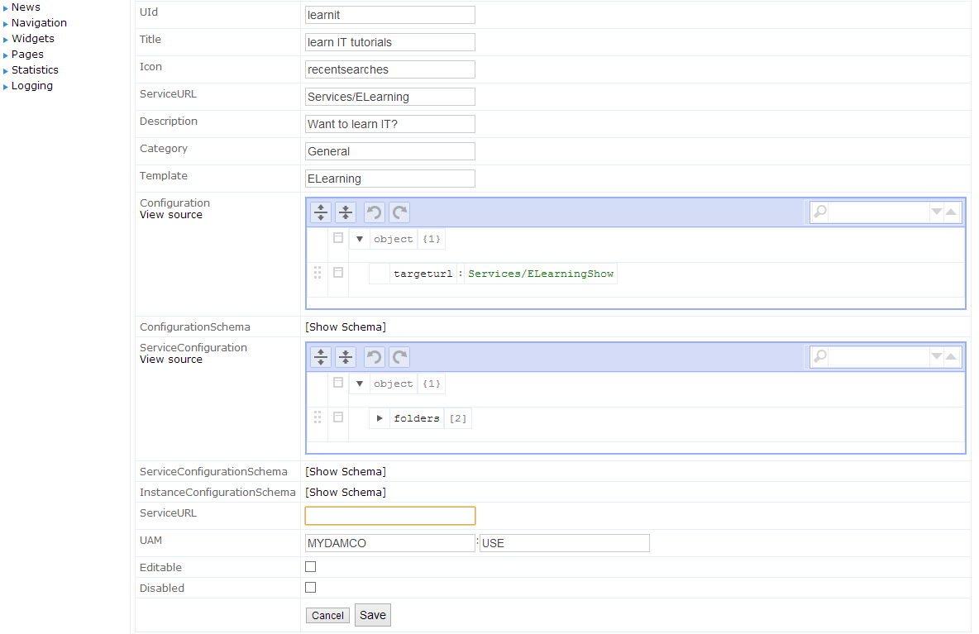

Figure 16: Edit widget form.

Validate the information is typed in as in the screenshot above.

The content the e-learning widget displays are stored in .swf (Flash). These files must be copied into folders on the server specified in the Service Configuration field. In this tutorial the folders are: C: \newlearning\SystemB and C:\ newlearning\SystemA (The sharp eye will have spotted double backslashes in paths copied into the Service Configuration field. This is necessary for programming reasons).

The names shown in the e-learning widget, are simply the filenames of the .swf files (without the .swf).

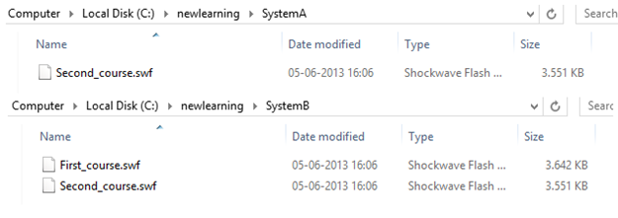

Figure 17: Content of the SystemA and SystemB folders.

Now you can add the widget to your myDamco.

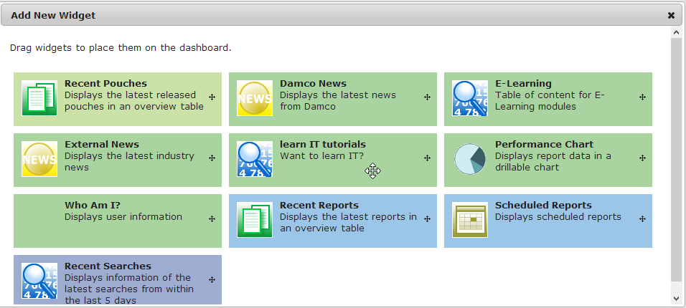

Figure 18: New Learn IT tutorials are now in Add New Widget screen.

The available courses, corresponding to the files in the folders on the server, looks like below:

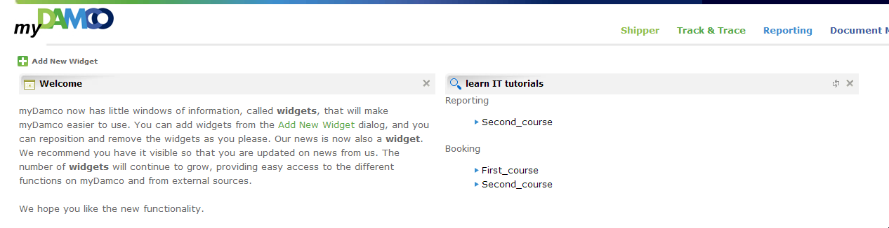

Figure 19: New e-learning widget now works.

# Pages

This section of the administration tool, allows you to create so called static pages. In other words, it allows you to create simple web pages in a very easy fashion.

For example, most of the links in the footer of myDamco, points to pages made by this tool (Cookies, Privacy policy, Terms of Use and Disclaimer). The text of these pages can be edited using this tool, and you can create new pages.

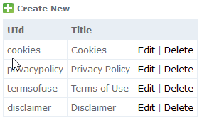

Figure 20: The default pages (shown in the footer).

Note that if you create a new page, it will not show up in the footer. Only the four pages mentioned above are setup specifically to appear in the footer. New pages will not automatically show up anywhere. For users to access the new pages you create, they have to go to a special link (see below).

## Creating a new page

To create a new static page you simply click the “Create New” button.

You must enter a UID, which must be unique among all of the static pages, then a title and the body text of your new page. Note that the UID is used as part of the URL to the page.

After having pressed "Create" to create the page, the page can be accessed by going to the URL:

[https://portal.damco.com/](https://portal.damco.com/termsofuse)<uid>

where <uid> is the UID you entered when you created the page.

For example, you can go directly to the "Terms of use" page by directing your browser to:

<https://portal.damco.com/termsofuse>

since its UID is "termsofuse".

# Statistics

The statistics page of the administration tool shows a few interesting statistics about myDamco.

The upper table shows information about how often the various widgets are used. The count column for a widget shows how many widgets of this type is currently placed on a dashboard. The percentage column, shows how many widgets of this type have been placed on a dashboard out of all widgets placed on all dashboards. In other words, it shows which widget is the most popular. Note that some widgets have access restrictions which can count against their popularity.

The lower table shows information about the server at which myDamco is running.

At the bottom, the build time is shown (the time at which the currently running version of myDamco was built).

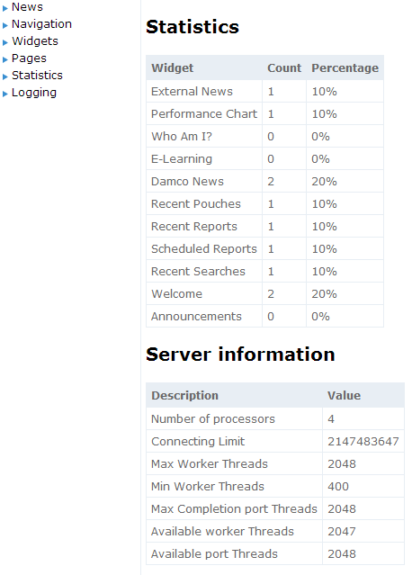

Figure 21: Statistics page.

# Settings

The settings section of the administration tool, contains some settings which can be changed dynamically (while the application is running).

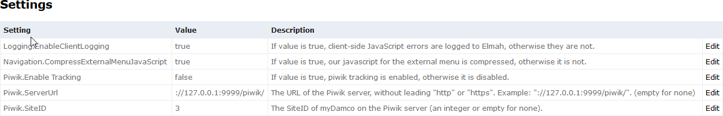

Figure 22: Settings page.

You can change the value of a setting, by clicking the “Edit” button next to it. For each setting, there is a description, briefly describing what the setting is about and what you can use as a value for it.

Currently there are only a few settings in this section:

* **Logging:** 
  + **Enable Client Logging:** *(values: true/false)*  
    This is mostly for developers. It specifies whether to also log client-side JavaScript errors occurring in the users browsers to the Elmah error log, in addition to the server-side errors which are always logged.
* **Navigation:** 
  + **Compress External Menu JavaScript:** *(values: true/false)*  
    This is mostly for developers. It specifies whether to minimize the javascript files which are used in the external menu.
* **Piwik:** 
  + **Enable Tracking:** *(values: true/false)*This specifies whether to enable Piwik tracking on myDamco or not. It provides an easy way to disable tracking (maybe temporarily), by setting this setting to “false”.   
    (Note: Will not take effect for users, until they reload their page or go to another page in their browser, so it may take a short while for data to completely stop arriving at piwik, if it is changed it from true to false).  
    Note, in order for Piwik tracking to work, the “ServerURL” and “SiteID” must also be set, in addition to setting this setting to “true”.
  + **Server URL:** *(values: the URL of the Piwik server, without leading “https” – or empty)*This specifies the URL of the Piwik server that myDamco has to send its tracking data to, and must obviously be sat in order for Piwik tracking to work.
  + **Site ID:** *(values: an integer – the site-ID of myDamco on the Piwik server – or empty)*

This specifies the “Site ID” that myDamco has been assigned to on the Piwik server. It is required to be sat correctly in order for Piwik tracking to work.

When changing a setting there will be a short delay before the changes takes effect (currently up to 30 seconds). This is because myDamco is caching the values of these settings in memory for a short while, so that it does not need to constantly reload them from the database (i.e. it is to reduce database load).

# Dashboard Templates

Normally when a user logs on to myDamco for the first time, the dashboard contains only the welcome widget. In some cases, it would be nice to be able to predefine which widgets a certain group of users should have on their dashboard when they log in for the first time, instead of only showing the welcome widget. This is the purpose of Dashboard Templates.

Briefly put a dashboard template is a template of a dashboard. A dashboard template applies to a specific role only – this is how it targets a specific group of users. Like a normal dashboard, a dashboard template contains a number of widgets. The widgets of a dashboard template will be copied to the users when they log in to myDamco with that role for the first time. (or to be more precise: when their dashboard is empty for that role and they load the dashboard page [4]).

All users who are in the role of the dashboard template will now be greeted with the widgets you selected for the dashboard template, instead of the welcome widget, when they first log in (or when they delete all their widgets and reload the page). This includes the placement of the widgets on the dashboard and the state of the widgets, such as which reports or news-feeds they show. For example, you can add a pie-chart widget to the dashboard template showing a report of your choosing (including filters), and you can add an external news widget to the dashboard template showing a specific news feed. The users will see the same report (if they have access to it) and news feed, when they login for the first time.

In the admin interface you can create new dashboard templates. Creating a new dashboard template for a specific role, works by **copying** the dashboard from a user into the template. For example, you can copy from yourself. Before creating a dashboard template, you must place the widgets on your own dashboard as you want them to be initially placed on the users dashboard when they first log in with that role. This includes which reports[5] you want to be shown in the pie-charts (if any), etc. When you are satisfied, go to the admin tool and create the dashboard template from your own dashboard (see below). Alternatively, you can copy the dashboard from someone else instead, if another person has sat up his dashboard like it should be in the template.

After the dashboard has been copied into the dashboard template, you can freely change your dashboard again without it affecting the dashboard template. (The dashboard template is only copied to, when the template is manually created or edited, it does not happen automatically behind the scenes)

## How to create a dashboard template

You create a new Dashboard Template by clicking the “Create New” button. This will open the dialog shown on the following figure:

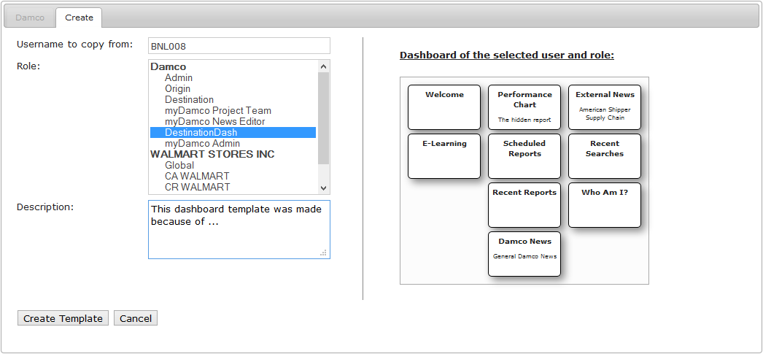

Figure 23: Create Dashboard Template dialog. A preview of the user’s dashboard is shown at the right.

First, enter the login name of a user whose dashboard you want to copy to the dashboard template.

Second, select a role. A preview of the dashboard of the selected user and role is shown, when you click a role. This preview shows the positions of the widgets on the dashboard, as well as their type and possibly their title. The selected role will both be used to 1) select which of the selected user’s dashboards to copy into the template and is also 2) specifies which role the dashboard template will apply to (all users of this role will get the dashboard template instead of the usual welcome widget).

Third, enter a description of the dashboard template. This is visible only to other admins. Use it to communicate to other admins why you created the dashboard template.

Finally, click the “Create Template” button to create the template.

**How to test it:**

To test that your dashboard template looks correct, you can go to your dashboard (click the “myDamco” logo) and change into the same role as you created a dashboard template for. After this, delete all widgets from your dashboard and reload the page in the browser afterwards (press F5). Now the dashboard template has been copied to your dashboard (instead of the usual welcome widget) and you can check whether it looks correct.

If a user which has already logged in with the role in question, and thus already has a non-empty dashboard, would like to get the widgets from the dashboard template, this is also the way he can get that – i.e. delete all his widgets and reload the page.

**Ensure that all users in the role has access to any reports you include:**

You will perhaps include one or more widgets, which shows a specific report in your dashboard template, such as the pie-chart widget. As mentioned, a dashboard template applied to all users of the role you selected, so before creating the dashboard template, you should make sure that all the users of that role has access to the report. (otherwise the widget will tell them that they don’t have access to the report)

## How to update a dashboard template

Updating a dashboard template works exactly like creating a new template – in fact, you can think of it as deleting the old template and creating a new. You select a user to copy the dashboard from, select which role to copy the dashboard from (which is also the role of the users it will apply to) and enter a description. (Note: If you select a different role than before, the dashboard template will now apply to that role, and not the role it did before).

The main change is that in the edit dialog, you can also see a preview of what the current dashboard template looks like, in addition to seeing the dashboard of the selected user and role.

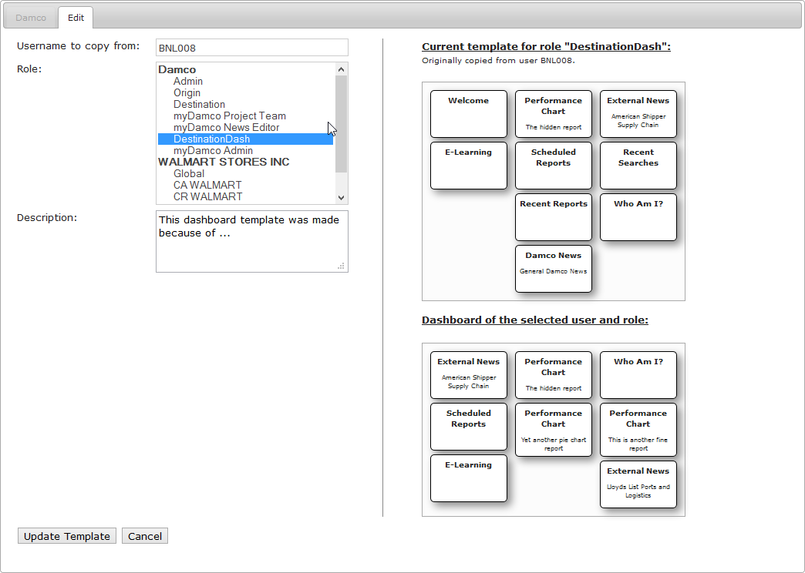

Figure 24: Edit Dashboard Template dialog. This time it both shows a preview of the current template and the dashboard of the user. The template will be replaced with the user’s dashboard, if you click “update template”.

## Refreshing organizations and roles from UAM

It may seldom happen that organization names or roles are changed in the UAM. These changed are not automatically propagated to MyDamco. To synchronize cached data in the MyDamco database from UAM the “Refresh cached names” button in the upper right corner of the “Dashboard Templates” screen may be used.

# Server management

The server management section of the administration tool, allows for certain operations related to administration of the server. This section is mostly intended to be used by myDamco developers or by admins after having discussed an issue with a developer. This section allows you to delete the ELMAH log and to clear the JavaScript and CSS cache.

The ELMAH log is a log of various kinds of errors recorded by the myDamco system. This log is useful for myDamco developers to trace down problems. Since deleting the log will remove the history of errors, it should only be done after consulting a developer.

ELMAH logs can be viewed in myDamco, under Administration -> Server Management -> View the ELMAH Log.

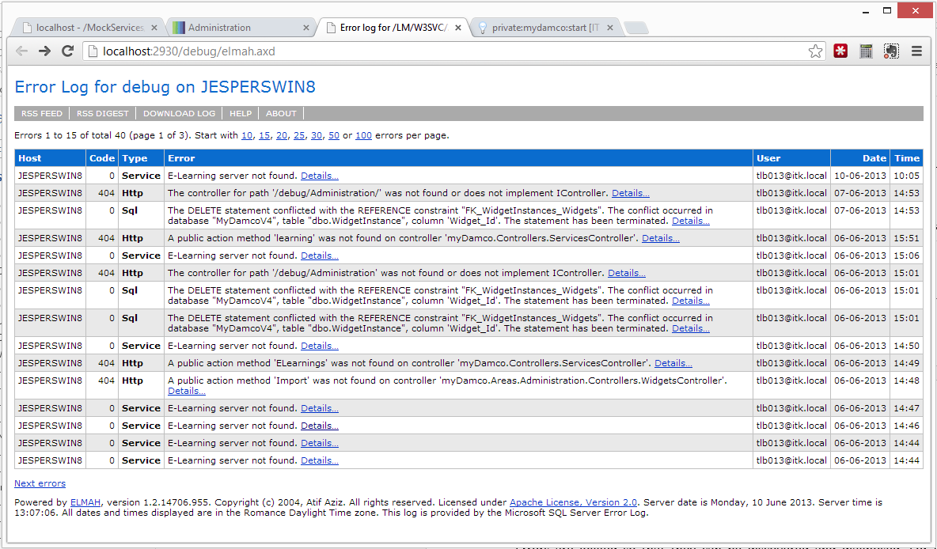

Figure 25: Example of exceptions caught in ELMAH log.

In case a specific problem has occurred during the deployment of the myDamco application, in which old JavaScript and CSS files (from an old deployment) are still being served to the user, deleting the JavaScript and CSS cache should correct the problem and cause the new files to be served.

1. For current UTC time, please refer to: <http://www.worldtimeserver.com/current_time_in_UTC.aspx>
2. <http://www.timeanddate.com/worldclock/city.html?n=1440>
3. For a screenshot of what this shield-icon looks like, see: <https://support.zendesk.com/entries/27879356-iFrames-issues-Chrome-and-FFox-security-updates>
4. So another way that the users can make the widgets of your dashboard template appear, is to delete all the widgets on their dashboard and reload the page. Normally, this will make the Welcome-widget reappear, but if you have made a dashboard template for their role, the widgets of your dashboard template will appear instead. This is also a good way to test your template yourself.
5. You should ensure that all users who are in that role has access to that report – see below.